9

APPLICATION: INTERNATIONAL TRADE

WHAT’S NEW IN THE SEVENTH EDITION:

A new In the News feature on “Threats to Free Trade” has been added.

LEARNING OBJECTIVES:

By the end of this chapter, students should understand:

➢ what determines whether a country imports or exports a good.

➢ who wins and who loses from international trade.

➢ that the gains to winners from international trade exceed the losses to losers.

➢ the welfare effects of tariffs and import quotas.

➢ the arguments people use to advocate trade restrictions.

CONTEXT AND PURPOSE:

Chapter 9 is third in a three-chapter sequence dealing with welfare economics. Chapter 7 introduced welfare economics: the study of how the allocation of resources affects economic well-being. Chapter 8 applied the lessons of welfare economics to taxation. Chapter 9 applies the tools of welfare economics from Chapter 7 to the study of international trade, a topic that was first introduced in Chapter 3.
The purpose of Chapter 9 is to use welfare economics to address the gains from trade more precisely than in Chapter 3, which discussed comparative advantage and the gains from trade. This chapter develops the conditions that determine whether a country imports or exports a good and discusses who wins and who loses when a country imports or exports a good. This chapter will show that when free trade is allowed, the gains of the winners exceed the losses of the losers. Because there are gains from trade, restrictions on free trade reduce the gains from trade and cause deadweight losses similar to those generated by a tax.

KEY POINTS:

• The effects of free trade can be determined by comparing the domestic price without trade to the world price. A low domestic price indicates that the country has a comparative advantage in producing the good and that the country will become an exporter. A high domestic price indicates that the rest of the world has a comparative advantage in producing the good and that the country will become an importer.

• When a country allows trade and becomes an exporter of a good, producers of the good are better off, and consumers of the good are worse off. When a country allows trade and becomes an importer of a good, consumers are better off, and producers are worse off. In both cases, the gains from trade exceed the losses.

• A tariff—a tax on imports—moves a market closer to the equilibrium that would exist without trade and, therefore, reduces the gains from trade. Although domestic producers are better off and the government raises revenue, the losses to consumers exceed these gains.

• There are various arguments for restricting trade: protecting jobs, defending national security, helping infant industries, preventing unfair competition, and responding to foreign trade restrictions. Although some of these arguments have merit in some cases, economists believe that free trade is usually the better policy.

CHAPTER OUTLINE:


This chapter may be difficult to teach and very difficult for students to understand and accept. Be prepared for a skeptical reaction from students who have been told that free international trade is detrimental to a country. For various historical, cultural, and political reasons, free trade has few defenders outside of the economics profession.

Point out that international trade issues are no different from trading as it applies to individuals within a community or between states and regions within a country. The gains from trade between countries occur for the same reasons that we observe gains from trade between individuals.

Pick a state adjacent to yours. Ask students why we do not seem to worry about “importing” goods from other states the same way in which we worry about importing goods from other countries.



I. The Determinants of Trade

A. Example used throughout the chapter: The market for textiles in a country called Isoland.

B. The Equilibrium without Trade

1. If there is no trade, the domestic price in the textile market will balance supply and demand.

Figure 1

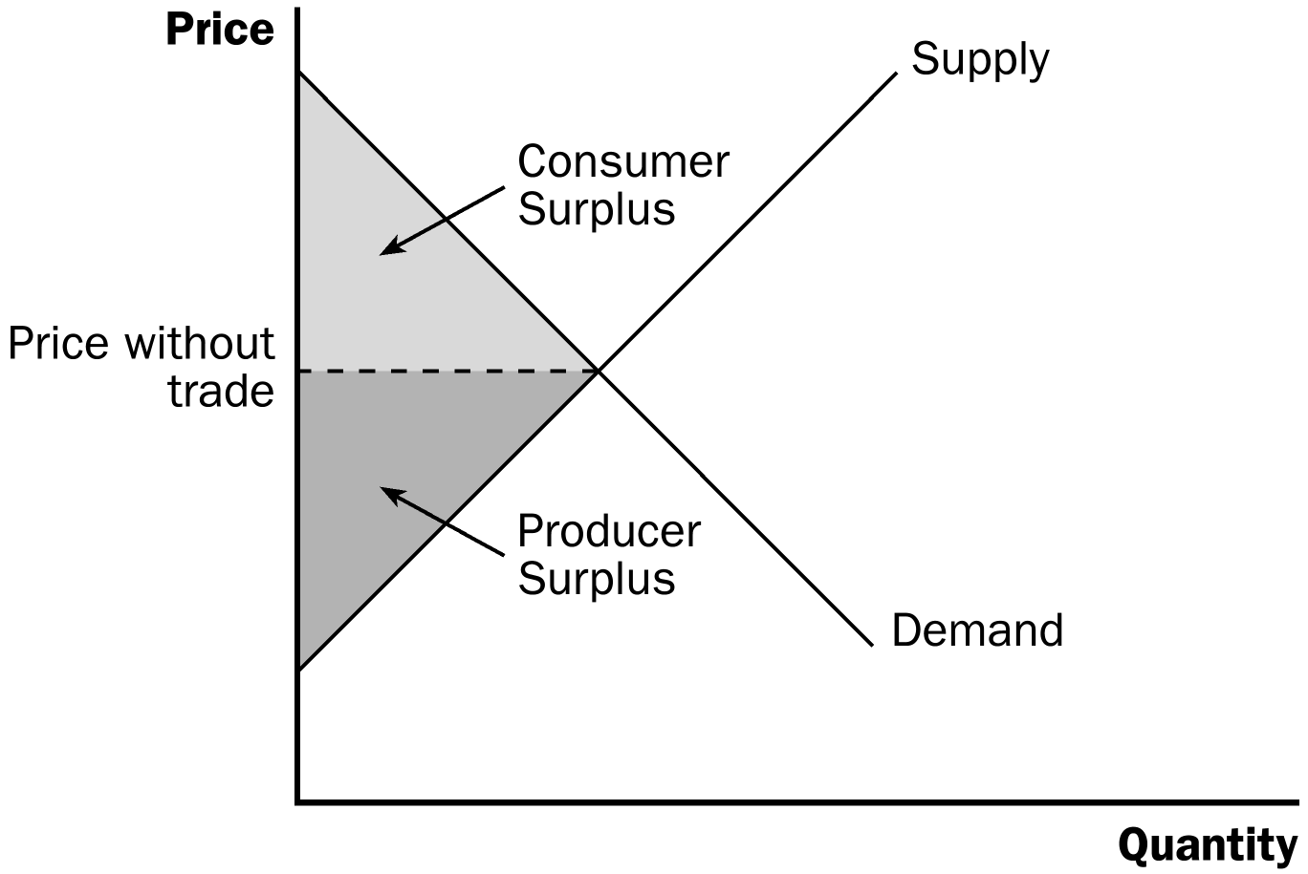

2. A new leader is elected who is interested in pursuing trade. A committee of economists is organized to determine the following:

a. If the government allows trade, what will happen to the price of textiles and the quantity of textiles sold in the domestic market?

b. Who will gain from trade, who will lose, and will the gains exceed the losses?

c. Should a tariff (a tax on imported textiles) be part of the new trade policy?

C. The World Price and Comparative Advantage

1. The first issue is to decide whether Isoland should import or export textiles.

a. The answer depends on the relative price of textiles in Isoland compared with the price of textiles in other countries.

b. Definition of world price: the price of a good that prevails in the world market for that good.

2. If the world price is greater than the domestic price, Isoland should export textiles; if the world price is lower than the domestic price, Isoland should import textiles.

a. Note that the domestic price represents the opportunity cost of producing textiles in Isoland, while the world price represents the opportunity cost of producing textiles abroad.

b. Thus, if the domestic price is low, this implies that the opportunity cost of producing textiles in Isoland is low, suggesting that Isoland has a comparative advantage in the production of textiles. If the domestic price is high, the opposite is true.

II. The Winners and Losers from Trade

A. We can use welfare analysis to determine who will gain and who will lose if free trade begins in Isoland.

B. We will assume that, because Isoland would be such a small part of the market for textiles, they will be price takers in the world economy. This implies that they take the world price as given and must sell (or buy) at that price.

C. The Gains and Losses of an Exporting Country

1. If the world price is higher than the domestic price, Isoland will export textiles. Once free trade begins, the domestic price will rise to the world price.

2. As the price of textiles rises, the domestic quantity of textiles demanded will fall and the domestic quantity of textiles supplied will rise. Thus, with trade, the domestic quantity demanded will not be equal to the domestic quantity supplied.

Have students come to the board and label the areas of consumer and producer surplus after you have drawn each of the figures. This should not be a problem as they are likely familiar enough with consumer and producer surplus after completing Chapters 7 and 8.

Figure 2
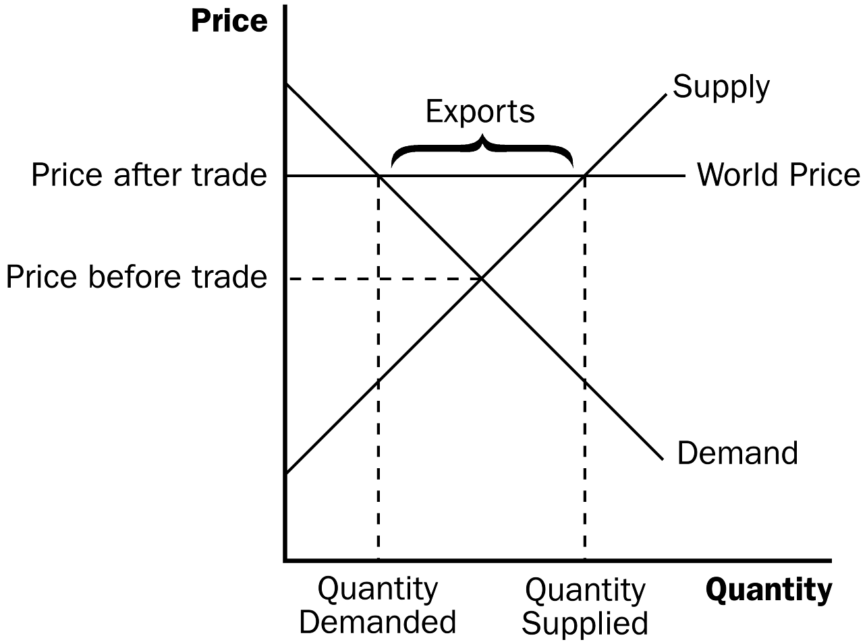
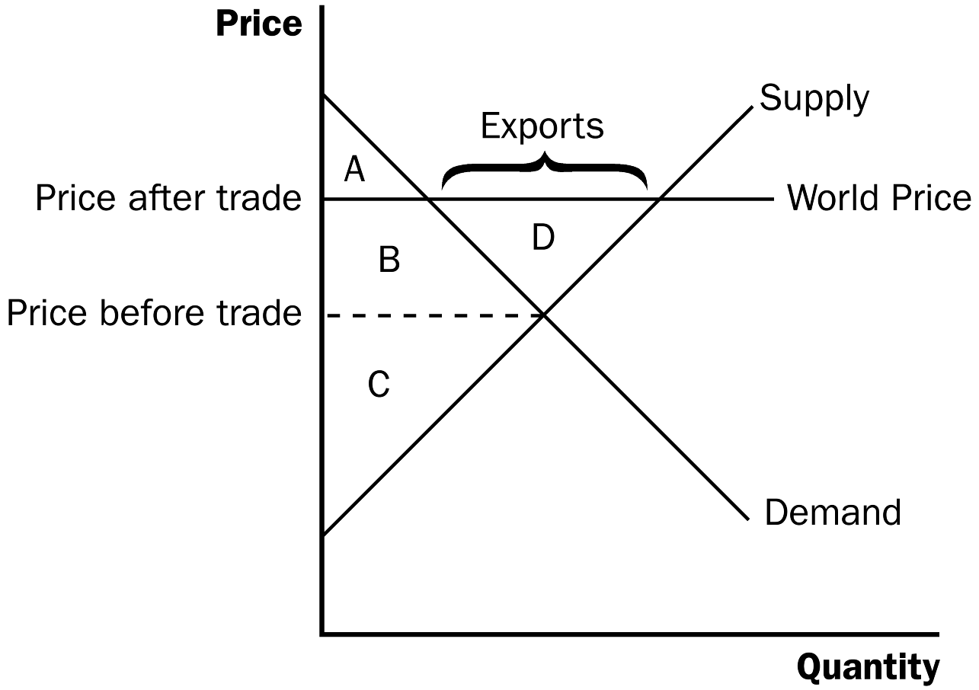

3. Welfare without Trade

a. Consumer surplus is equal to: A + B.

b. Producer surplus is equal to: C.

c. Total surplus is equal to: A + B + C.

4. Welfare with Trade

a. Consumer surplus is equal to: A.

b. Producer Surplus is equal to: B + C + D.

c. Total surplus is equal to: A + B + C + D.

5. Changes in Welfare

a. Consumer surplus changes by: –B.

b. Producer surplus changes by: +B + D.

c. Total surplus changes by: +D.

6. When a country exports a good, domestic producers of the good are better off and domestic consumers of the good are worse off.

7. When a country exports a good, total surplus is increased and the economic well-being of the country rises.

D. The Gains and Losses of an Importing Country

1. If the world price is lower than the domestic price, Isoland will import textiles. Once free trade begins, the domestic price will fall to the world price.

2. As the price of textiles falls, the domestic quantity of textiles demanded will rise and the domestic quantity of textiles supplied will fall.

a. Thus, with trade, the domestic quantity demanded will not be equal to the domestic quantity supplied.

b. Isoland will import the difference between the domestic quantity demanded and the domestic quantity supplied.
Note that there will be both imported and domestically produced textiles sold in this country. This is true for many imported goods.

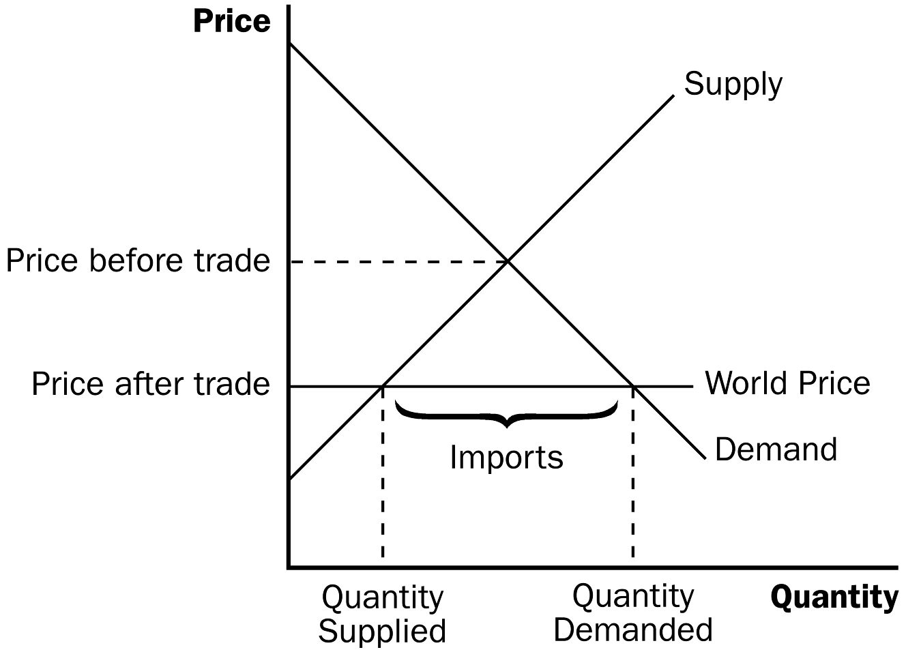
Figure 3

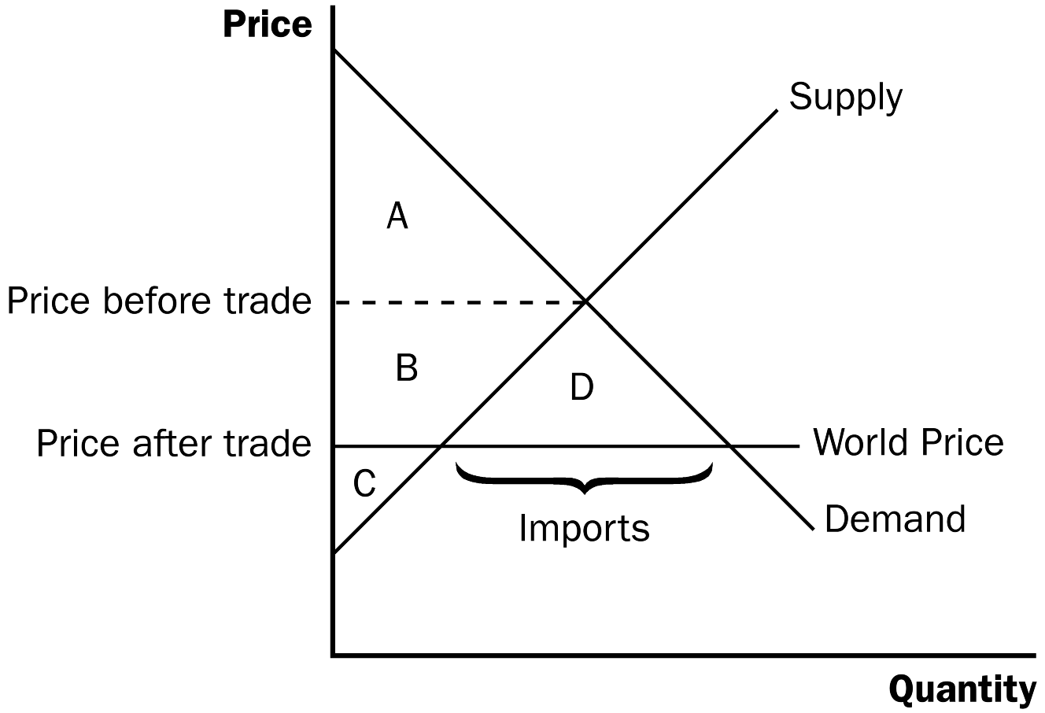
3. Welfare without Trade

a. Consumer surplus is equal to: A.

b. Producer surplus is equal to: B + C.

c. Total surplus is equal to: A + B + C.

4. Welfare with Trade

a. Consumer surplus is equal to: A + B + D.

b. Producer surplus is equal to: C.

c. Total surplus is equal to: A + B + C + D.

5. Changes in Welfare

a. Consumer surplus changes by: +B + D.

b. Producer surplus changes by: –B.

c. Total surplus changes by: +D.

6. When a country imports a good, domestic consumers of the good are better off and domestic producers of the good are worse off.

7. When a country imports a good, total surplus is increased and the economic well-being of the country rises.
Be prepared for students to argue that trade cannot be good for everyone. More than likely at least one of your students will know an individual who lost his or her job when a factory closed and moved to another country. Take this opportunity to point out that this individual is one of the “losers,” but remind the class that the gains from trade exceed the losses, so the total well-being of society is increased.

Point out that during the 1990s with open trading (for example, the passage of NAFTA), the U.S. economy achieved and maintained full employment even as large quantities of imported goods entered the United States. Most of the jobs that “left the country” were low-skill, low-wage jobs.

E. Trade policy is often contentious because the policy creates winners and losers. If the losers have political clout, the result is often trade restrictions such as tariffs and quotas.

F. The Effects of a Tariff

1. Definition of tariff: a tax on goods produced abroad and sold domestically.

2. A tariff raises the price above the world price. Thus, the domestic price of textiles will rise to the world price plus the tariff.

3. As the price rises, the domestic quantity of textiles demanded will fall and the domestic quantity of textiles supplied will rise. The quantity of imports will fall and the market will move closer to the domestic market equilibrium that occurred before trade.

4. Welfare before the Tariff (with trade)

a. Consumer surplus is equal to: A + B + C + D + E + F.

b. Producer surplus is equal to: G.

c. Government revenue is equal to: zero.

d. Total surplus is equal to: A + B + C + D + E + F + G.
Figure 4

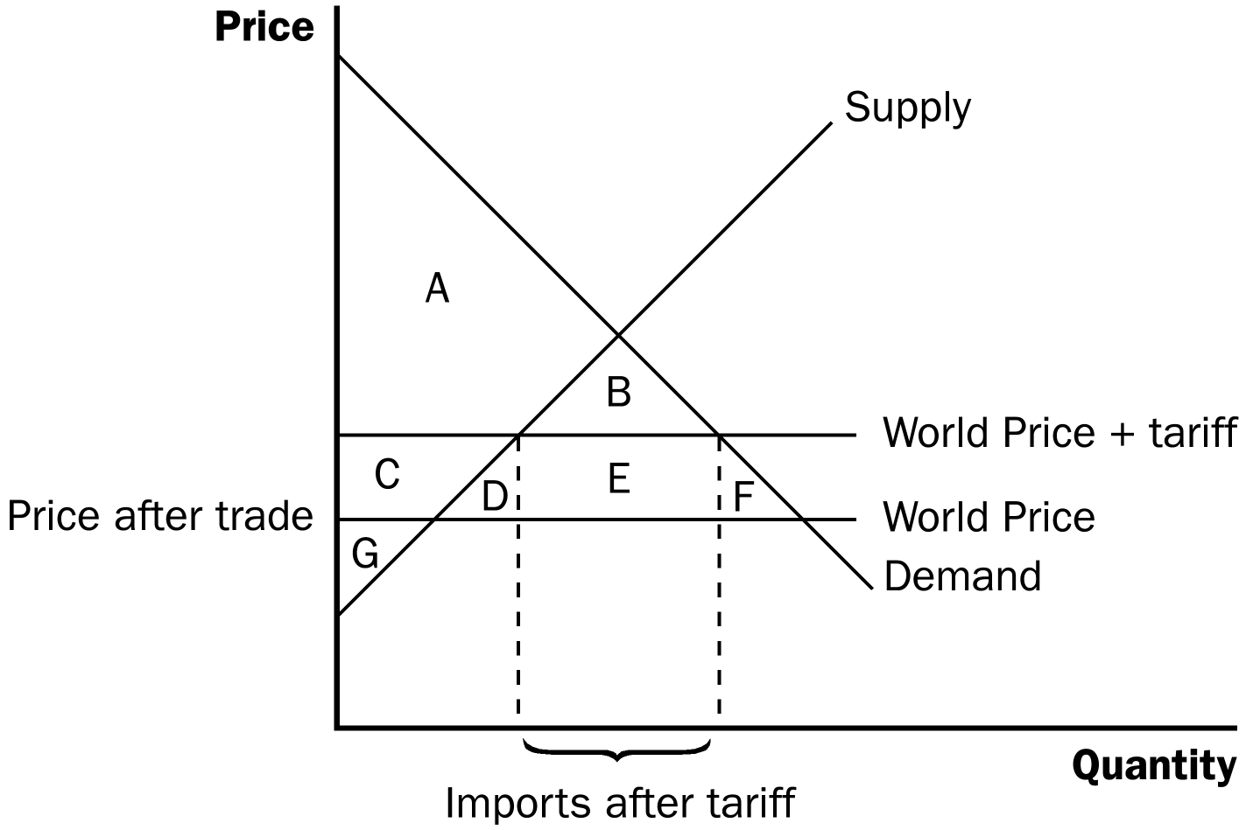

5. Welfare after the Tariff

a. Consumer surplus is equal to: A + B.

b. Producer surplus is equal to: C + G.

c. Government revenue is equal to: E.

d. Total surplus is equal to: A + B + C + E + G.

6. Changes in Welfare

a. Consumer surplus changes by: –C - D - E - F).

b. Producer surplus changes by: +C.

c. Government revenue changes by: +E.

d. Total surplus changes by: –D - F.

G. FYI: Import Quotas: Another Way to Restrict Trade

1. An import quota is a limit on the quantity of a good that can be produced abroad and sold domestically.

2. Import quotas are much like tariffs.

a. Both tariffs and quotas raise the domestic price of the good, reduce the welfare of domestic consumers, increase the welfare of domestic producers, and cause deadweight losses.

b. However, a tariff raises revenue for the government, whereas a quota creates surplus for license holders.

c. A quota can potentially cause a larger deadweight loss than a tariff, depending on the mechanism used to allocate the import licenses.

H. The Lessons for Trade Policy

This section provides a good opportunity to review what the students have learned thus far about trade. You should reinforce the idea that total surplus rises when trade is introduced, but falls once trade restrictions are imposed.

1. If trade is allowed, the price of textiles will be driven to the world price. If the domestic price is higher than the world price, the country will become an importer and the domestic price will fall. If the domestic price is lower than the world price, the country will become an exporter and the domestic price will rise.

2. If a country imports a product, domestic producers are made worse off, domestic consumers are made better off, and the gains of consumers outweigh the losses of producers. If a country exports a product, domestic producers are made better off, domestic consumers are made worse off, and the gains of producers outweigh the losses of consumers.

3. A tariff would create a deadweight loss because total surplus would fall.

I. In the News: Threats to Free Trade

1. In the wake of the recent deep recession, policymakers around the world imposed trade restrictions.

2. This article from The Wall Street Journal describes the increase in protectionist policies.

J. Other Benefits of International Trade

1. In addition to increasing total surplus, there are several other benefits of free trade.

2. These include an increased variety of goods, lower costs through economies of scale, increased competition, and an enhanced flow of ideas.

III. The Arguments for Restricting Trade

A. The Jobs Argument

1. If a country imports a product, domestic producers of the product will have to lay off workers because they will decrease domestic output when the price declines to the world price.

2. Free trade, however, will create job opportunities in other industries where the country enjoys a comparative advantage.

B. In the News: Should the Winners from Free Trade Compensate the Losers?

1. In light of the jobs argument, some people argue for taxpayer-subsidized retraining programs to help those who lose their jobs due to free trade.

2. This opinion piece from The New York Times focuses on the net gains from trade and argues for no compensation for the losers from trade by drawing parallel examples from daily life.

C. The National-Security Argument

1. Protecting certain industries may be appropriate if they produce products necessary for national security.

2. In many of the cases for which this argument is used, the role of the particular market in providing national security is exaggerated.

D. The Infant-Industry Argument

1. New industries need time to establish themselves to be able to compete in world markets.

2. Sometimes older industries argue that they need temporary protection to help them adjust to new conditions.

3. Even if this argument is legitimate, it is nearly impossible for the government to choose which industries will be profitable in the future and it is even more difficult to remove trade restrictions in an industry once they are in place.

E. The Unfair-Competition Argument

1. It is unfair if firms in one country are forced to comply with more regulations than firms in another country, or if another government subsidizes the production of a good.

2. Even if another country is subsidizing the production of a product so that it can be exported to a country at a lower price, the domestic consumers who import the product gain more than the domestic producers lose.

F. In the News: Second Thoughts about Free Trade

1. Some economists worry about the impact of international trade on the distribution of income.

2. This article from The New York Times expresses such concerns.

G. The Protection-as-a-Bargaining-Chip Argument

1. Threats of protectionism can make other countries more willing to reduce the amounts of protectionism they use.

2. If the threat does not work, the country has to decide if it would rather reduce the economic well-being of its citizens (by carrying out the threat) or lose credibility in negotiations (by reneging on its threat).

H. Case Study: Trade Agreements and the World Trade Organization

1. Countries wanting to achieve freer trade can take two approaches to cutting trade restrictions: a unilateral approach or a multilateral approach.

2. A unilateral approach occurs when a country lowers its trade restrictions on its own. A multilateral approach occurs when a country reduces its trade restrictions while other countries do the same.

3. The North America Free Trade Agreement (NAFTA) and the General Agreement on Tariffs and Trade (GATT) are multilateral approaches to reducing trade barriers.

4. The rules established under GATT are now enforced by the World Trade Organization (WTO).

5. The functions of the WTO are to administer trade agreements, provide a forum for negotiation, and handle disputes that arise among member countries.

Make sure that you point out the conclusion in this chapter. The chapter ends with a very effective parable about the discovery of comparative advantage, its adoption, its beneficial consequences, and finally, its abandonment for political reasons.

SOLUTIONS TO TEXT PROBLEMS:

Quick Quizzes

1. Since wool suits are cheaper in neighboring countries, Autarka would import suits if it were to allow free trade.

2. Figure 1 shows the supply and demand for wool suits in Autarka. With no trade, the price of suits is 3 ounces of gold, consumer surplus is area A, producer surplus is area B + C, and total surplus is area A + B + C. When trade is allowed, the price falls to 2 ounces of gold, consumer surplus rises to A + B + D (an increase of B + D), producer surplus falls to C (a decline of B), so total surplus rises to A + B + C + D (an increase of D). A tariff on suit imports would reduce the increase in consumer surplus, reduce the decline in producer surplus, and reduce the gain in total surplus.

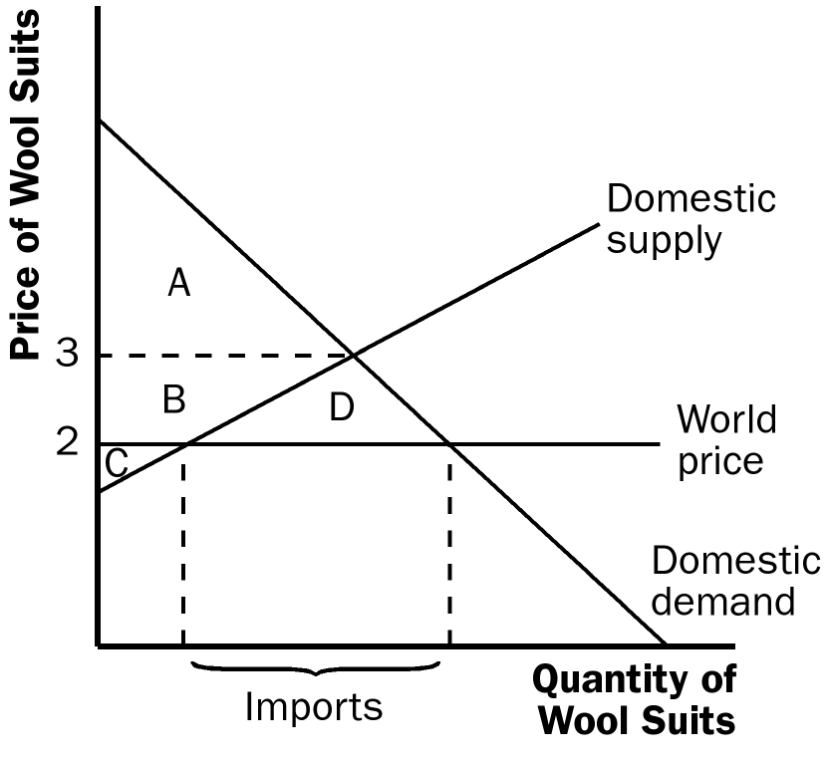

Figure 1

3. Lobbyists for the textile industry might make five arguments in favor of a ban on the import of wool suits: (1) imports of wool suits destroy domestic jobs; (2) the wool-suit industry is vital for national security; (3) the wool-suit industry is just starting up and needs protection from foreign competition until it gets stronger; (4) other countries are unfairly subsidizing their wool-suit industries; and (5) the ban on the importation of wool suits can be used as a bargaining chip in international negotiations.

In defending free trade in wool suits, you could argue that: (1) free trade creates jobs in some industries even as it destroys jobs in the wool-suit industry and allows Autarka to enjoy a higher standard of living; (2) the role of wool suits for the military may be exaggerated; (3) government protection is not needed for an industry to grow on its own; (4) it would be good for the citizens of Autarka to be able to buy wool suits at a subsidized price; and (5) threats against free trade may backfire, leading to lower levels of trade and lower economic welfare for everyone.

Questions for Review

1. If the domestic price that prevails without international trade is above the world price, the country does not have a comparative advantage in producing the good. If the domestic price is below the world price, the country has a comparative advantage in producing the good.

2. A country will export a good for which its domestic price is lower than the prevailing world price. Thus, if a country has a comparative advantage in producing a good, it will become an exporter when trade is allowed. A country will import a product for which its domestic price is greater than the prevailing world price. Thus, if a country does not have a comparative advantage in producing a good, it will become an importer when trade is allowed.

3. Figure 2 illustrates supply and demand for an importing country. Before trade is allowed, consumer surplus is area A and producer surplus is area B + C. After trade is allowed, consumer surplus is area A + B + D and producer surplus is area C. The change in total surplus is an increase of area D.

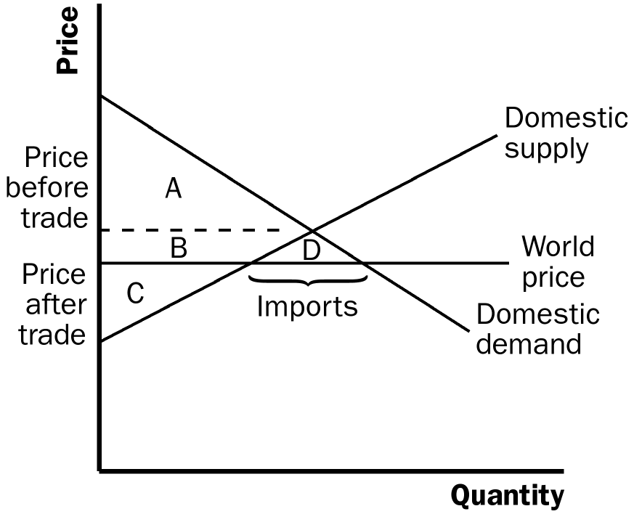

Figure 2

4. A tariff is a tax on goods produced abroad and sold domestically. If a country is an importer of a good, a tariff reduces the quantity of imports and moves the domestic market closer to its equilibrium without trade, increasing the price of the good, reducing consumer surplus and total surplus, while raising producer surplus and government revenue.

5. The arguments given to support trade restrictions are: (1) trade destroys jobs; (2) industries threatened with competition may be vital for national security; (3) new industries need trade restrictions to help them get started; (4) some countries unfairly subsidize their firms, so competition is not fair; and (5) trade restrictions can be useful bargaining chips. Economists disagree with these arguments: (1) trade may destroy some jobs, but it creates other jobs; (2) arguments about national security tend to be exaggerated; (3) the government cannot easily identify new industries that are worth protecting; (4) if countries subsidize their exports, doing so simply benefits consumers in importing countries; and (5) bargaining over trade is a risky business, because it may backfire, making the country worse off without trade.

6. A unilateral approach to achieving free trade occurs when a country removes trade restrictions on its own. Under a multilateral approach, a country reduces its trade restrictions while other countries do the same, based on an agreement reached through bargaining. The unilateral approach was taken by Great Britain in the 1800s and by Chile and South Korea in recent years. Examples of the multilateral approach include NAFTA in 1993 and the GATT negotiations since World War II.

Quick Check Multiple Choice
1. a
2. c
3. a
4. b
5. c
6. d

Problems and Applications

1. a. Figure 4 illustrates the Canadian market for wine, where the world price of wine is P₁. The following table illustrates the results under the heading "P₁."
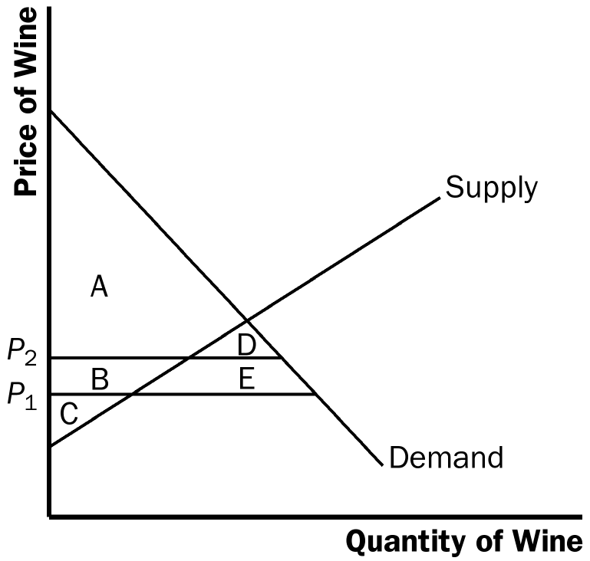

Figure 4

b. The shift in the Gulf Stream destroys some of the grape harvest in Europe and raises the world price of wine to P₂. The table shows the new areas of consumer, producer, and total surplus, as well as the changes in these surplus measures. Consumers lose, producers win, and Canada as a whole is worse off.

 | P₁ | P₂ | CHANGE
Consumer Surplus | A + B + D + E | A + D | –B - E
Producer Surplus | C | B + C | +B
Total Surplus | A + B + C + D + E | A + B + C + D | –E

2. The impact of a tariff on imported autos is shown in Figure 6. Without the tariff, the price of an auto is P_{W}, the quantity produced in the United States is Q₁^{S}, and the quantity purchased in the United States is Q₁^{D}. The United States imports Q₁^{D} – Q₁^{S} autos. The imposition of the tariff raises the price of autos to P_{W} + t, causing an increase in quantity supplied by U.S. producers to Q₂^{S} and a decline in the quantity demanded to Q₂^{D}. This reduces the number of imports to Q₂^{D} – Q₂^{S}. The table shows the areas of consumer surplus, producer surplus, government revenue, and total surplus both before and after the imposition of the tariff. Because consumer surplus declines by C + D + E + F while producer surplus rises by C and government revenue rises by E, the deadweight loss is D + F. The loss of consumer surplus in the amount C + D + E + F is split up as follows: C goes to producers, E goes to the government, and D + F is deadweight loss.

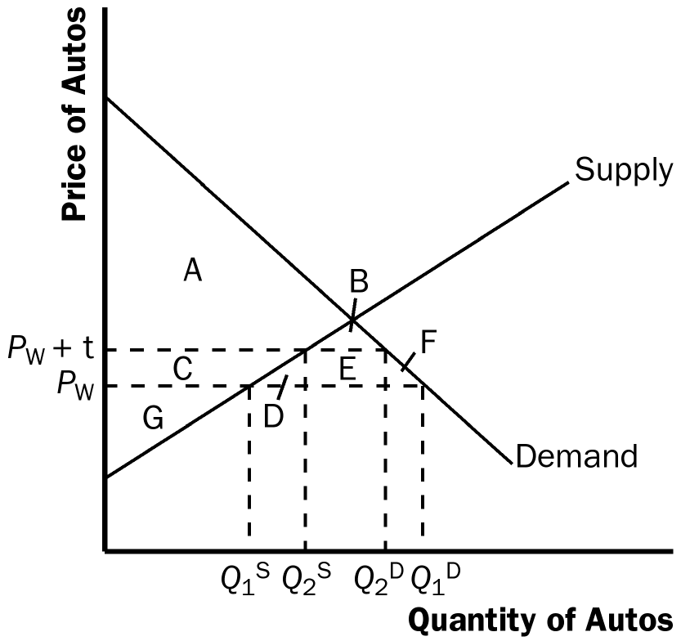

Figure 6

 | Before Tariff | After Tariff | CHANGE
Consumer Surplus | A + B + C + D + E + F | A + B | –C - D - E - F
Producer Surplus | G | C + G | +C
Government Revenue | 0 | E | +E
Total Surplus | A + B + C + D + E + F + G | A + B + C + E + G | –D - F

3. a. For a country that imports clothing, the effects of a decline in the world price are shown in Figure 7. The initial price is P_{w1} and the initial level of imports is Q^{d}₁ – Q^{s}₁. The new world price is P_{w2} and the new level of imports is Q^{d}₂ – Q^{s}₂. The table below shows the changes in consumer surplus, producer surplus, and total surplus. Domestic consumers are made better off, while domestic producers are made worse off. Total surplus rises by areas D + E + F.

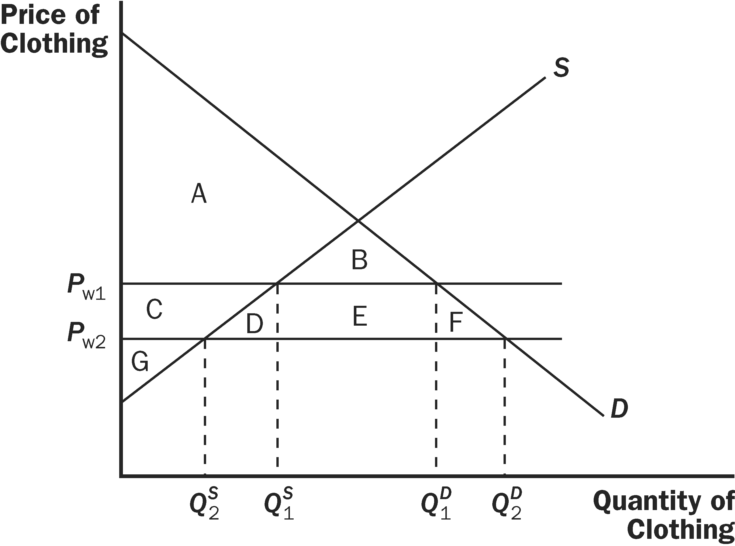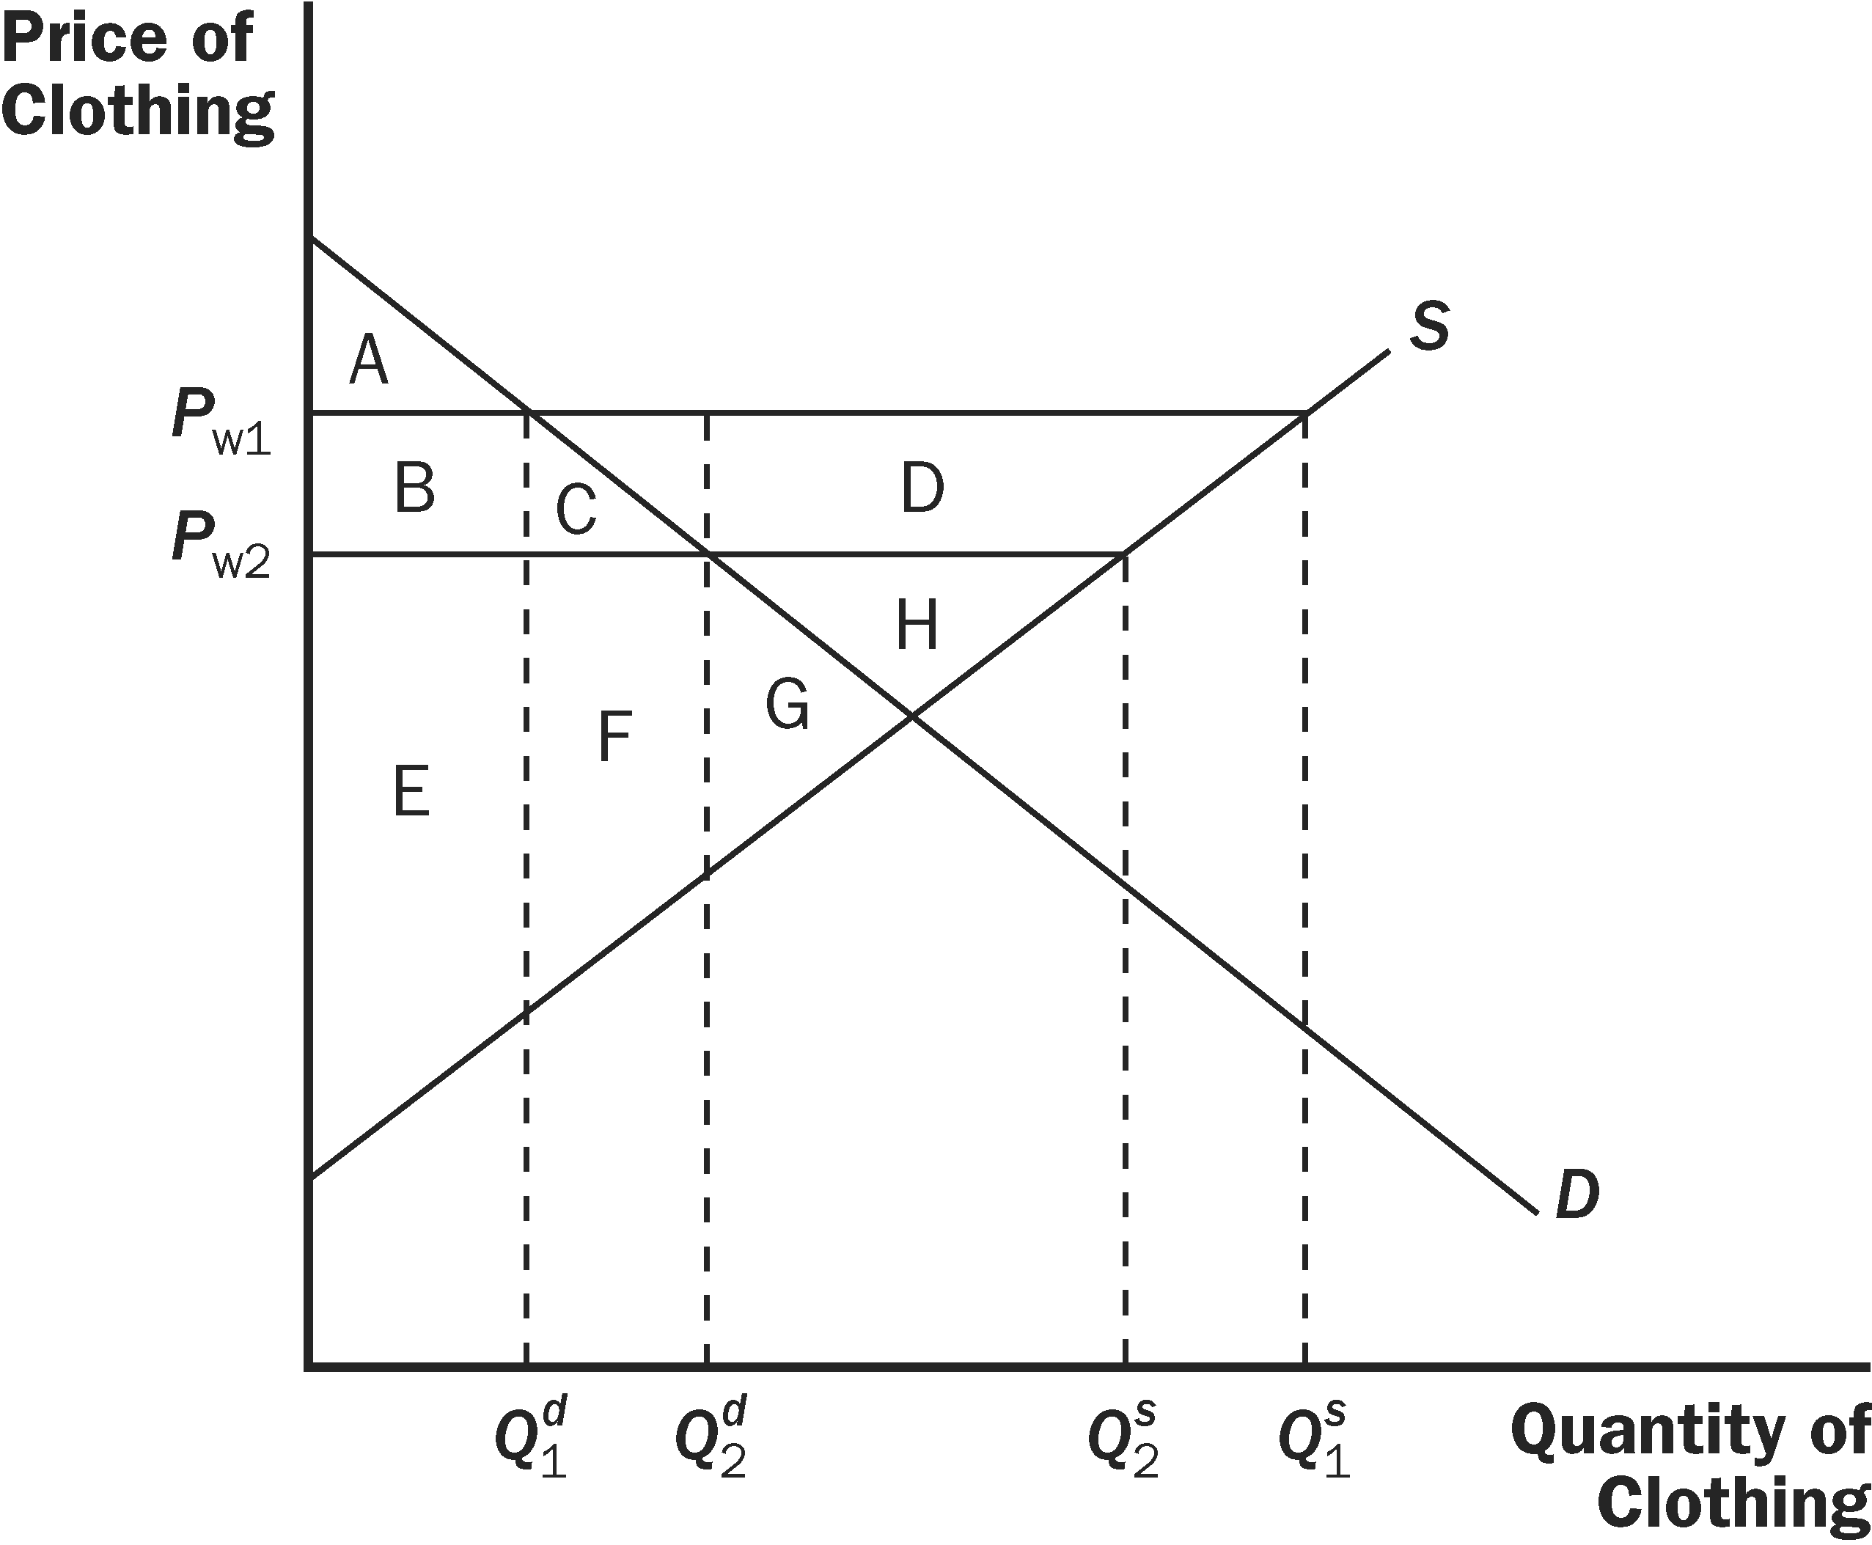
Figure 7 Figure 8

 | P_{w1} | P_{w2} | CHANGE
Consumer Surplus | A+B | A+B+C+D+E+F | C+D+E+F
Producer Surplus | C+G | G | –C
Total Surplus | A+C+G | A+B+C+D+E+F+G | D+E+F

b. For a country that exports clothing, the effects of a decline in the world price are shown in Figure 8. The initial price is P_{w1} and the initial level of exports is Q^{s}₁ – Q^{d}₁. The new world price is P_{w2} and the new level of exports is Q^{s}₂ – Q^{d}₂. The table below shows the changes in consumer surplus, producer surplus, and total surplus. Domestic consumers are made better off, while domestic producers are made worse off. Total surplus falls by area D.

 | P_{w1} | P_{w2} | CHANGE
Consumer Surplus | A | A + B + C | B + C
Producer Surplus | B + C + D + E + F + G + H | E + F + G + H | –B – C – D
Total Surplus | A + B + C + D + E + F + G + H | A + B + C + E + F + G + H | –D

c. Overall, importing countries benefit from the fall in the world price of clothing, while exporting countries are harmed.

4. a. While there are many possible answers, one correct answer is: the jobs argument and the unfair-competition argument. There are many workers employed in the timber industry and they may not be well-trained for jobs in other industries if free trade prevails and they lose their jobs due to less expensive imports. Other countries may impose less stringent regulations on the timber industry making competitors' production cheaper.

b. While there are many possible answers, one correct answer is: the national-security argument and the infant-industry argument. The economic rationale for the national-security argument is that if the product is necessary for national security, we should not rely on imports for the production of the good. The economic rationale against the national-security argument is that the proponents of trade restrictions may exaggerate the fact that the product is necessary for national security. The economic rationale for the infant-industry argument is that firms in industries just getting started need protection from foreign competition to become established in the industry. The economic rationale against the infant-industry argument is that it is very difficult for government to foresee which industries will be profitable and worth protecting.

5. a. Figure 9 shows the market for T-shirts in Textilia. The domestic price is $20 Once trade is allowed, the price drops to $16 and three million T-shirts are imported.

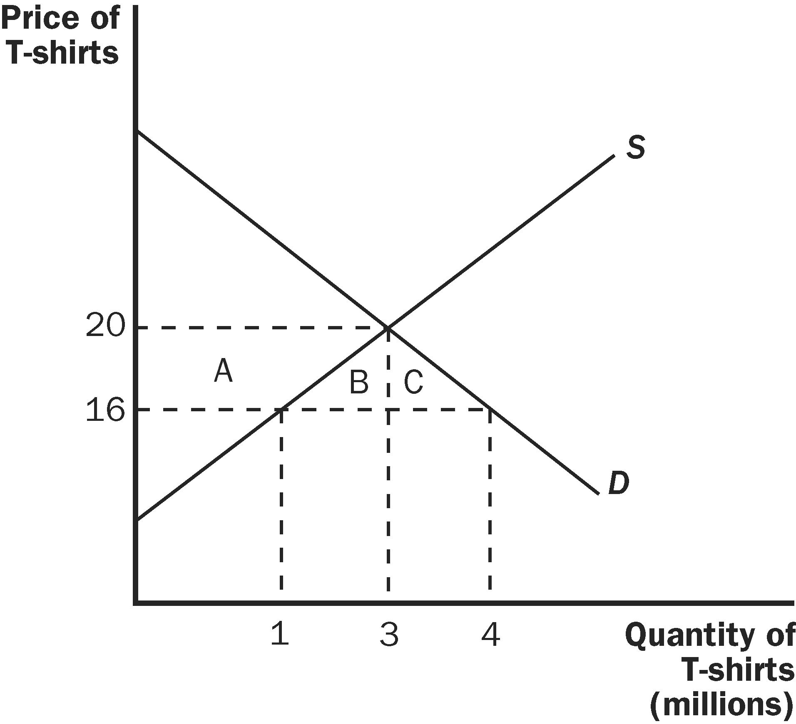

Figure 9

b. Consumer surplus increases by areas A + B + C. Area A is equal to ($4)(1 million) +(0.5)($4)(2 million) = $8 million. Area B is equal to (0.5)($4)(2 million) = $4 million. Area C is equal to (0.5)($4)(1 million) = $2 million. Thus, consumer surplus increases by $14 million.

Producer surplus declines by area A. Thus, producer surplus falls by $8 million.

Total surplus rises by areas B + C. Thus, total surplus rises by $6 million.

6. a. Figure 10 shows the market for grain in an exporting country. The world price is P_{W}.

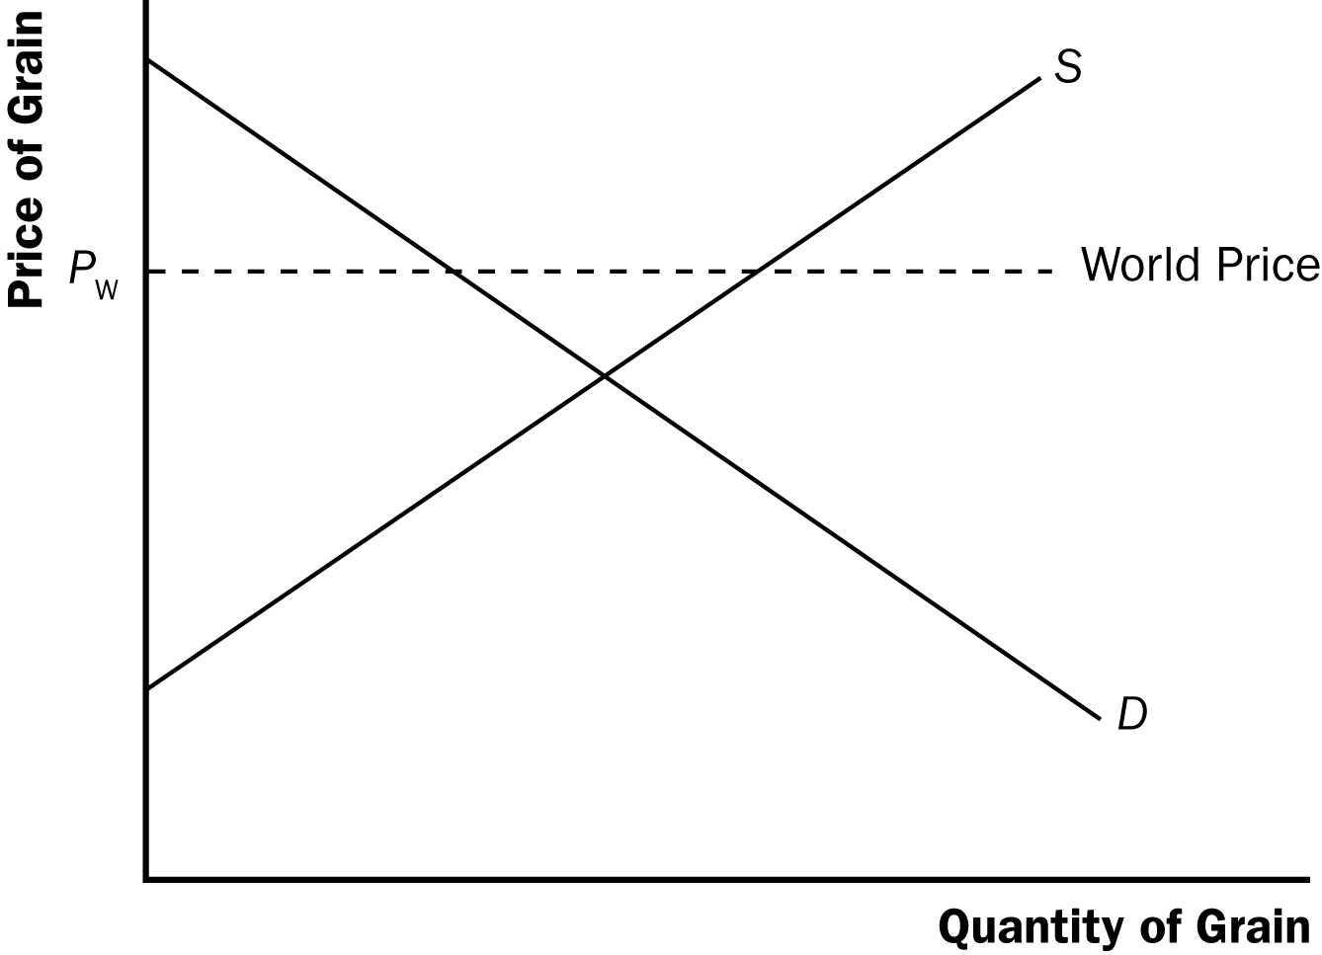

Figure 10

b. An export tax will reduce the effective world price received by the exporting nation.

c. An export tax will increase domestic consumer surplus, decrease domestic producer surplus, and increase government revenue.

d. Total surplus will fall because the decline in producer surplus is less than the sum of the changes in consumer surplus and government revenue. Thus, there is a deadweight loss as a result of the tax.

7. a. This statement is true. For a given world price that is lower than the domestic price, quantity demanded will rise more when demand is elastic. Therefore, the rise in consumer surplus will be greater when demand is elastic.

b. This statement is false. Quantity demanded would remain unchanged, but buyers would pay a lower price. This would increase consumer surplus. Domestic producer surplus will fall, but by less than the rise in consumer surplus. Gains from trade will increase.

c. This statement is false. Even though quantity demanded does not rise when trade is allowed, consumer surplus rises, because consumers are paying a lower price.

8. a. Figure 11 shows the market for jelly beans in Kawmin if trade is not allowed. The market equilibrium price is $4 and the equilibrium quantity is 4. Consumer surplus is $8, producer surplus is $8, and total surplus is $16.

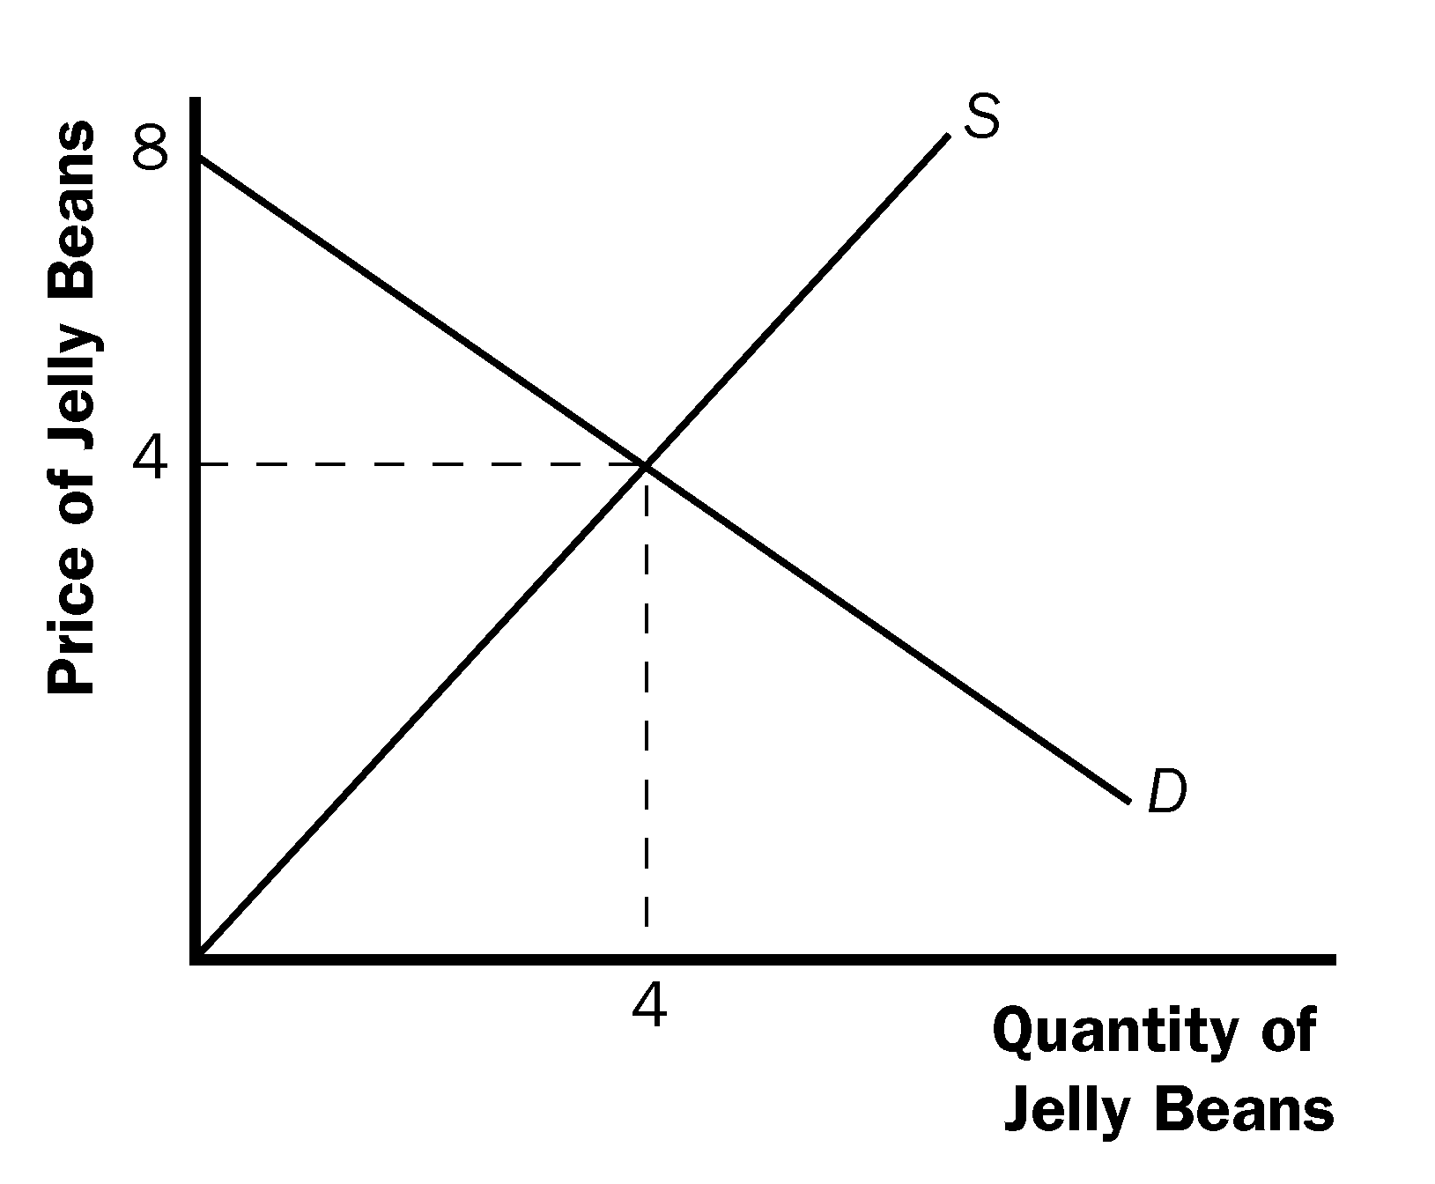

Figure 11

b. Since the world price is $1, Kawmin will become an importer of jelly beans. Figure 12 shows that the domestic quantity supplied will be 1, quantity demanded will be 7, and 6 bags will be imported. Consumer surplus is $24.50, producer surplus is $0.50, so total surplus is $25.

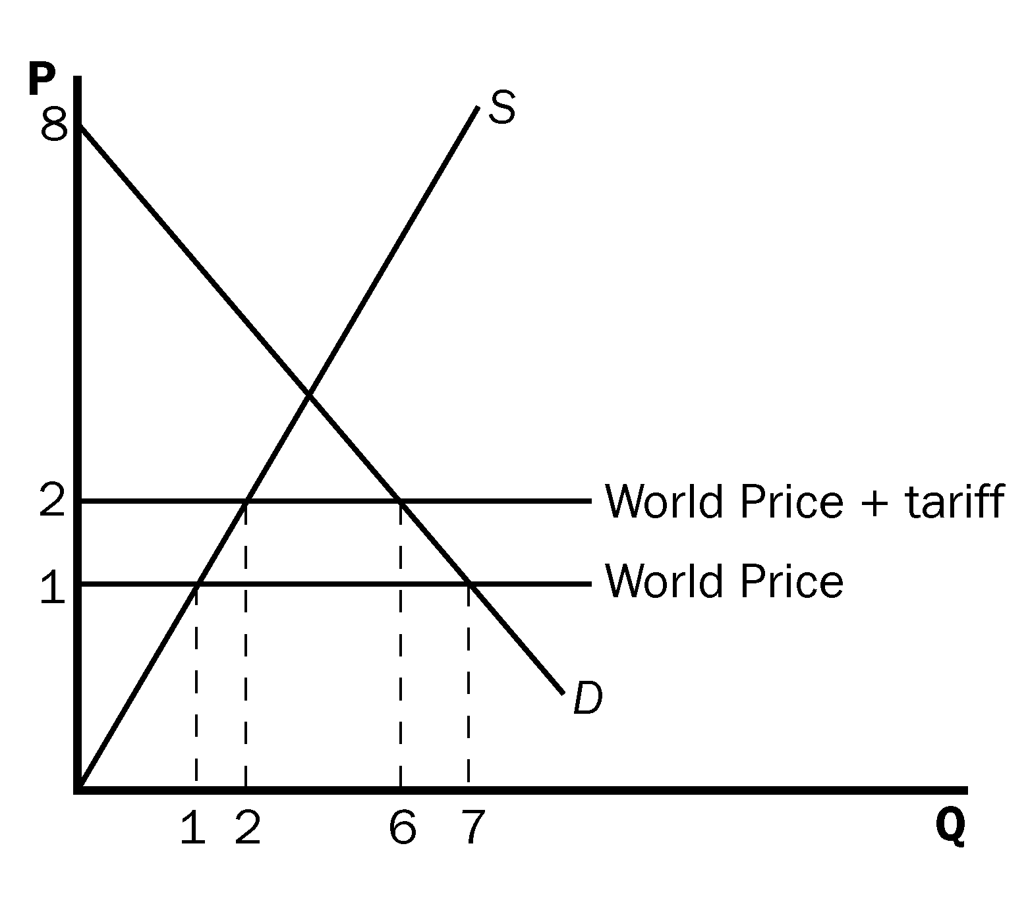

Figure 12

c. The tariff raises the world price to $2. This reduces domestic consumption to 6 bags and raises domestic production to 2 bags. Imports fall to 4 bags (see Figure 12). Consumer surplus is now $18, producer surplus is $2, government revenue is $4, and total surplus is $24.

d. When trade was opened, total surplus increases from $16 to $25. The deadweight loss of the tariff is $1 ($25 − $24).

9. a. Using Figure 4 from the text, the quantity demanded will fall to Q₂^{D}, the same quantity demanded under the tariff. However, quantity supplied will not change because the price sellers receive will be the world price. Thus, quantity supplied will remain at Q₁^{S}.

b. The effects of the consumption tax can be seen in the table below:

 | World price | World price + tax | CHANGE
Consumer Surplus | A + B + C + D + E + F | A + B | -C - D - E - F
Producer Surplus | G | G | None
Government Revenue | None | C + D + E | C + D + E
Total Surplus | A + B + C + D + E + F + G | A + B + C + D + E + G | -F

c. The consumption tax raises more government revenue because the tax is on all units (not just the imported units). Thus, the deadweight loss is smaller with the consumption tax than with a tariff.

10. a. When a technological advance lowers the world price of televisions, the effect on the United States, an importer of televisions, is shown in Figure 13. Initially the world price of televisions is P₁, consumer surplus is A + B, producer surplus is C + G, total surplus is A + B + C + G, and the amount of imports is shown as “Import₁”. After the improvement in technology, the world price of televisions declines to P₂ (which is P₁ – 100), consumer surplus increases by C + D + E + F, producer surplus declines by C, total surplus rises by D + E + F, and the amount of imports rises to “Import₂”.

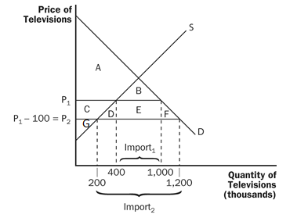

Figure 13

 | P₁ | P₂ | CHANGE
Consumer Surplus | A + B | A + B + C + D + E + F | C + D + E + F
Producer Surplus | C + G | G | –C
Total Surplus | A + B + C + G | A + B + C + D + E + F + G | D + E + F

b. The areas are calculated as follows: Area C = 200,000($100) + (0.5)(200,000)($100)
= $30 million. Area D = (0.5)(200,000)($100) = $10 million. Area E = (600,000)($100) = $60 million. Area F = (0.5)(200,000)($100) = $10 million.

Therefore, the change in consumer surplus is $110 million. The change in producer surplus is -$30 million. Total surplus rises by $80 million.

c. If the government places a $100 tariff on imported televisions, consumer and producer surplus would return to their initial values. That is, consumer surplus would fall by areas C + D + E + F (a decline of $110 million). Producer surplus would rise by $30 million. The government would gain tariff revenue equal to ($100)(600,000) = $60 million. The deadweight loss from the tariff would be areas D and F (a value of $20 million). This is not a good policy from the standpoint of U.S. welfare because total surplus is reduced after the tariff is introduced. However, domestic producers will be happier as they benefit from the tariff.

d. It makes no difference why the world price dropped in terms of our analysis. The drop in the world price benefits domestic consumers more than it harms domestic producers and total welfare improves.

11. An export subsidy increases the price of steel exports received by producers by the amount of the subsidy, s, as shown in Figure 14. The figure shows the world price, P_{W}, before the subsidy is put in place. At that price, domestic consumers buy quantity Q₁^{D} of steel, producers supply Q₁^{S} units, and the country exports the quantity Q₁^{S} – Q₁^{D}. With the subsidy put in place, suppliers get a total price per unit of P_{W} + s, because they receive the world price for their exports P_{W}, and the government pays them the subsidy of s. However, note that domestic consumers can still buy steel at the world price, P_{W}, by importing it. Domestic firms do not want to sell steel to domestic customers, because they do not get the subsidy for doing so. So domestic companies will sell all the steel they produce abroad, in total quantity Q₂^{S}. Domestic consumers continue to buy quantity Q₁^{D}. The country imports steel in quantity Q₁^{D} and exports the quantity Q₂^{S}, so net exports of steel are the quantity Q₂^{S} – Q₁^{D}. The end result is that the domestic price of steel is unchanged, the quantity of steel produced increases, the quantity of steel consumed is unchanged, and the quantity of steel exported increases. As the following table shows, consumer surplus is unaffected, producer surplus rises, government revenue declines, and total surplus declines.

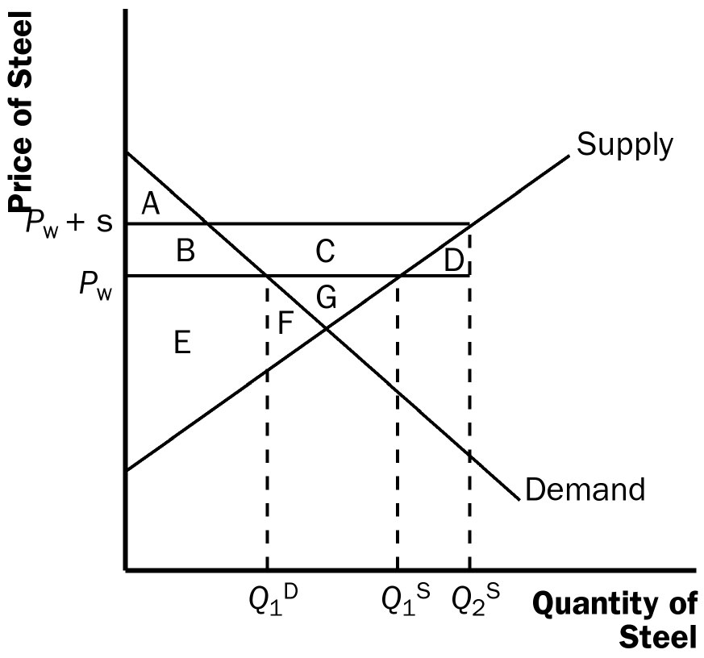

Figure 14

Thus, it is not a good policy from an economic standpoint because there is a decline in total surplus.

 | Without Subsidy | With Subsidy | CHANGE
Consumer Surplus | A + B | A + B | 0
Producer Surplus | E + F + G | B + C + E + F + G | +B + C
Government Revenue | 0 | –B - C - D | –B - C - D
Total Surplus | A + B + E + F + G | A + B – D + E + F + G | –D

